INSTRUCTIONS FOR XT PACKAGE MANAGER WITH XTSTREAMING

Creating TAR files

Creating tcp_server.tar

· Go to xt-streaming > tcp_server
Open setting.json
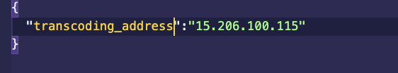
Update transcoding_tool address

· Open terminal run command docker build -t tcp_server .
· In same terminal run docker save -o tcp_server.tar tcp_server
· tcp_server.tar file has been generated.

Creating transcoding_tool.tar
· Go to xt-streaming > Video_transcoding_tool
· Open setting.json update the URL which tcp_server is running
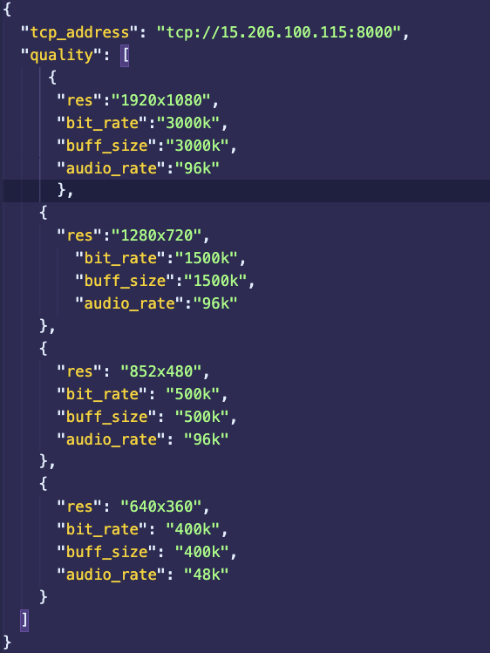
· Open terminal run command docker build -t transcoding_tool .
· In same terminal run docker save -o transcoding_tool.tar transcoding_tool

Adding files to IPFS
· Go to verification folder
· Create a folder with tcp_server and transcoding_tool
· Copy the generated tar files to the respective folder.
· run command Ipfs add -r tcp_server && ipfs add -r transcoding_tool

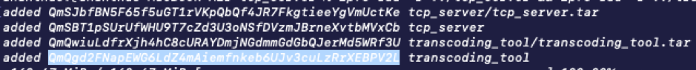
Note the cid value of tcp_server and transcoding_tool QmSBT1pSUrUfWHU9T7cZd3U3oNSfDVzmJBrneXvtbMVxCb and QmQgd2FNapEWG6LdZ4mAiemfnkeb6UJv3cuLzRrXEBPV2L

Generating Hash for TAR files
Copy the generated tar files to verification
· Go to verification folder
Open terminal run npm install
· Open path.json and update the relative path for tcp_server and transcoding_tool
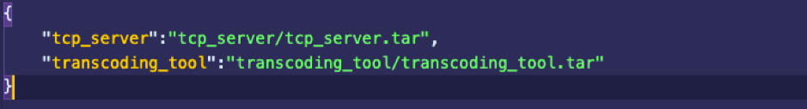
· Run command node individualFileHash.js

Note hash code for the respective tar file and update the hash value in XT-Package-Config.json

Updating destination path and port

Open XT-Package-Config.json update the value for Destination for each file
(Where the Xt-package manager should download files and deploy the docker tar file ).

Updating port

Open XT-Package-Config.json update the value for Port for each file to
Expose the port of the machine to the docker container.

Generating Hash for verification

· Go to the verification folder
· Run command node packageHashing.js
· Open XT-Package-config.json under verification
· Update the value of Hash , Signature,Public-Key

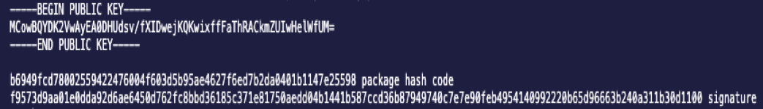

Adding XT-Package-Config.json to IPFS

· Go to verification folder
· Run command Ipfs add -r XT-Package-Config

Note the cid value of the XT-Package-ConfigQmc3m422wq3M15KqTdScofWShQzF97sdFZaa8pdF8qUN7T

To run XT-Package-Manager

· Copy the XTPM to respective Machine
· Go to XTPM
· Run npm install
· Open setting.json
· Update the packages which needed to download to the machine
· Update configCid with cid value of XT-Package-Config file which uploaded to ipfs
· Update the ipfs port with ipfs gateway running in respective machine
· Open terminal run command npm start to run XT-Package-Manager

To run XT-OBS

· Open obs.dmg and click on obs.app
· Go to settings button located at right bottom side of application
· Go to stream left side of panel
· Select XT-streaming
· Update Server with URL which tcp_server is running
· enter Stream key
· click on apply and then ok
· now click on start streaming button located at right bottom side of application.

To run Video Player

· Go to Video_player directory
· Open src/config.json
· Update the Transcoding_Tool with URL which transcoding_tool is running

· Open terminal run npm install && npm start
· Open browser and type http://localhost:3000

Video Player Build (To be hosted on a Web server)
- Go to Video_Player directory
- Open terminal run npm run build
- Copy the contents inside the build folder to the root of the web server.

Video Player Chrome Extension (Setting up)
- Copy the contents inside the build folder created in the previous step, to the Xtstreaming_Client_Chrome_Extension folder
- Open google chrome
- Open settings > More Tools > extension

- Click on load unpacked select Xtstreaming_Client_Chrome_Extension

Video Player Chrome Extension (for testing)
- Xtstreaming_Client_Chrome_Extension already contains the build files which can uploaded to chrome extension directly.

